STEP BY STEP APPROACH OF MY “YOUTUBE-API” WEB APPLICATION

For this app, we need to create a project in Google API

\* Enable the "YouTube Data API v3"

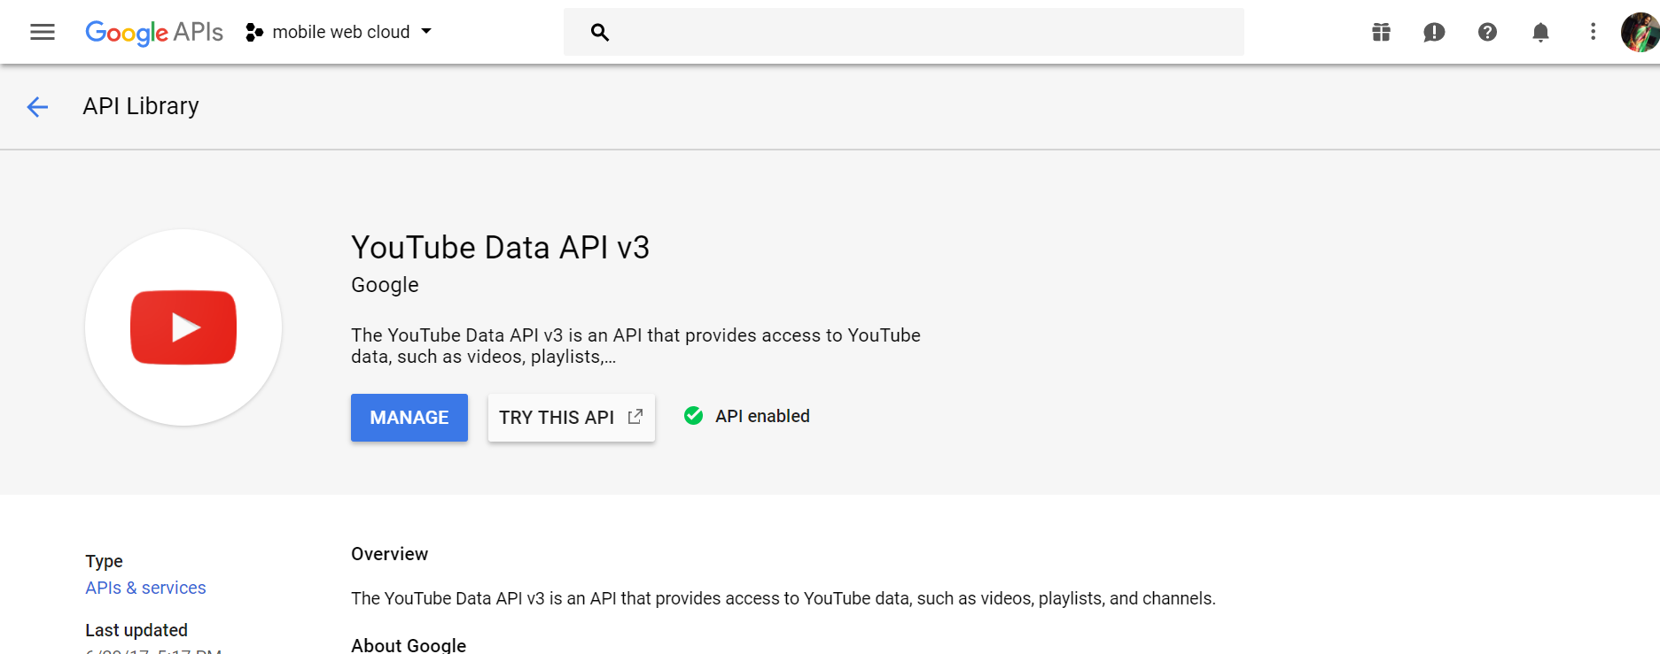

\* Create credentials to access API key

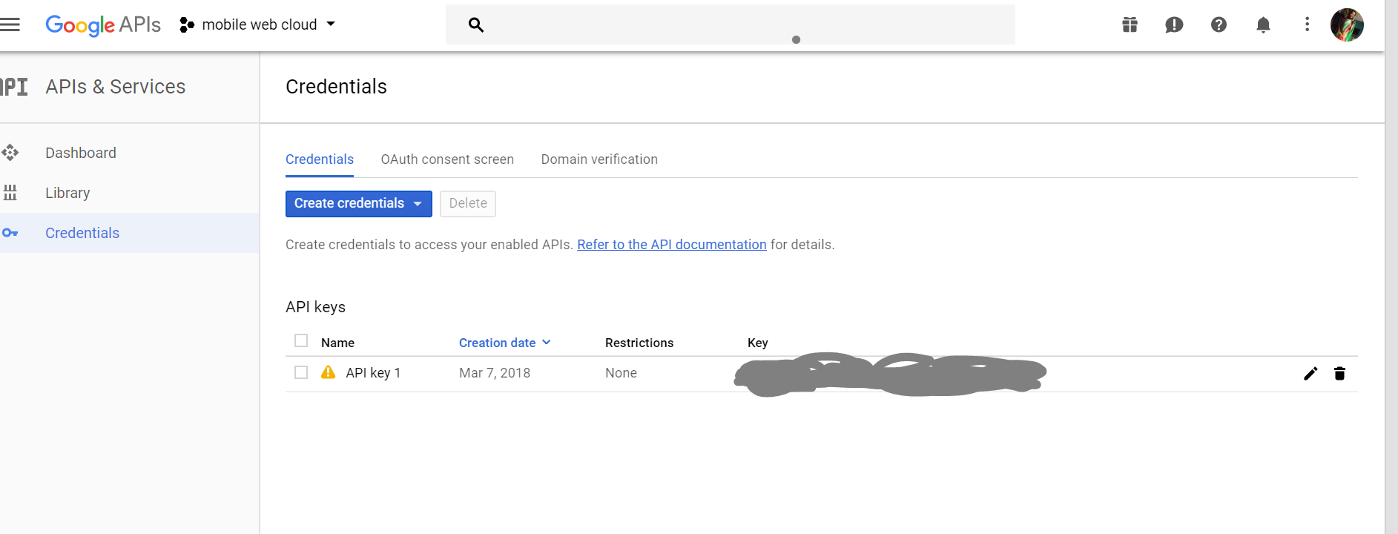

\* Use this client API key in the code to fetch YouTube data

The home page of my application looks like:

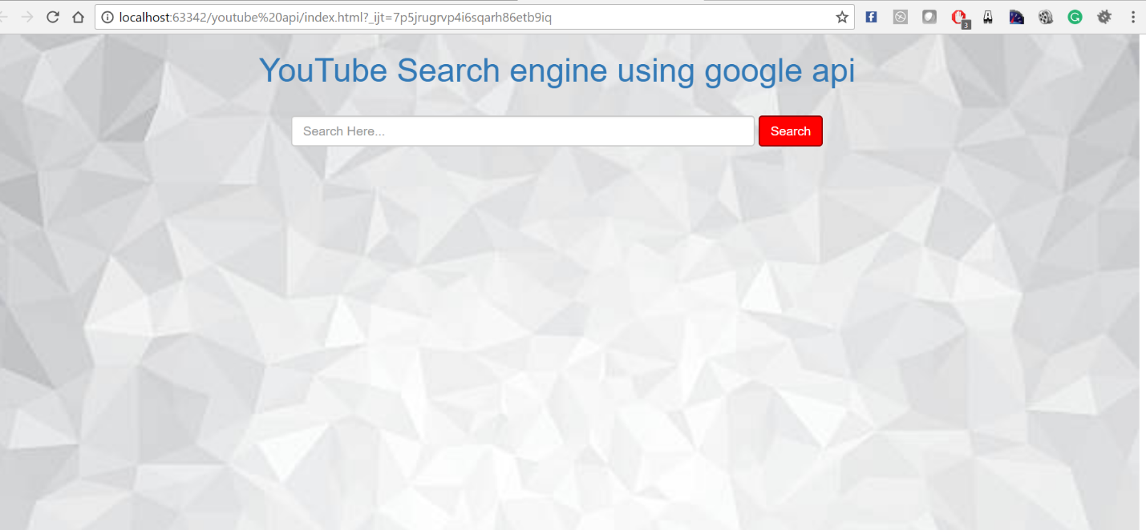

There are search bar and button, User can search for any keyword and hit the search button. The top 100 results are retrieved.

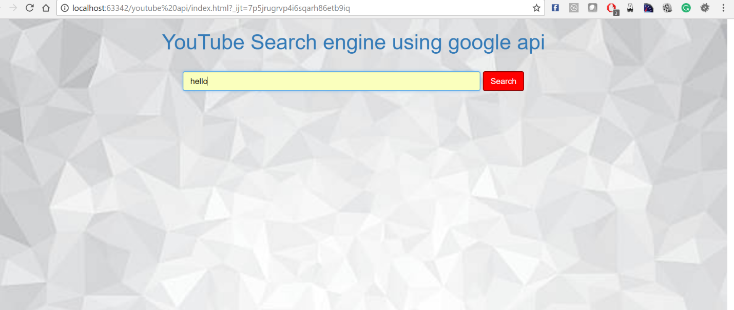

Results are:

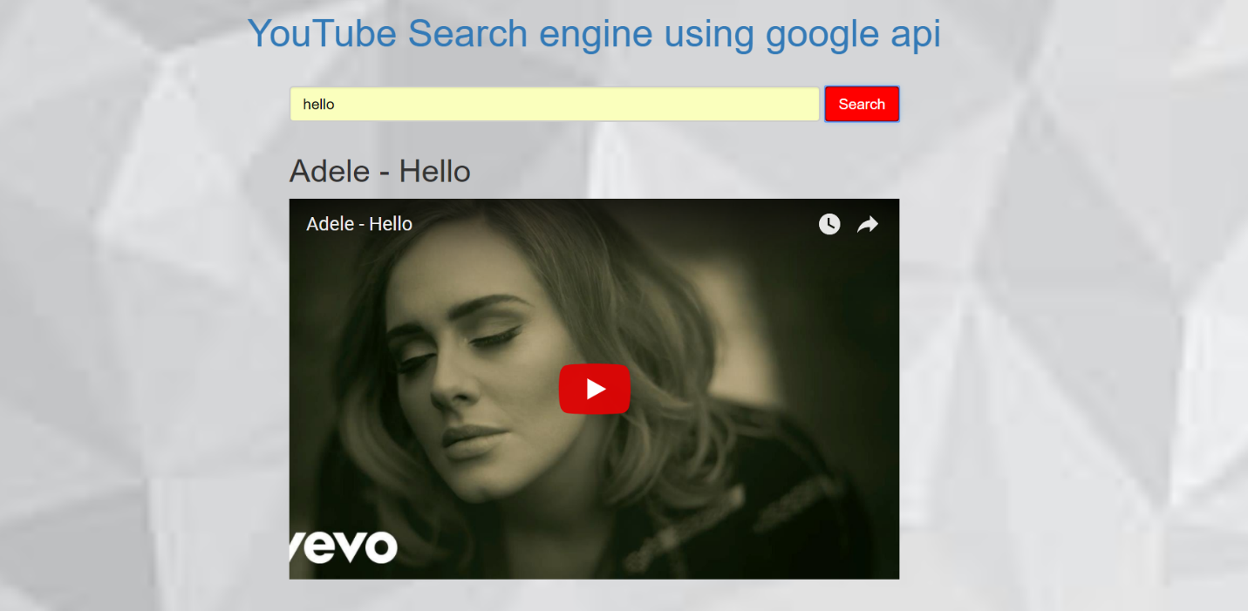

A user can hit play and pause the videos:

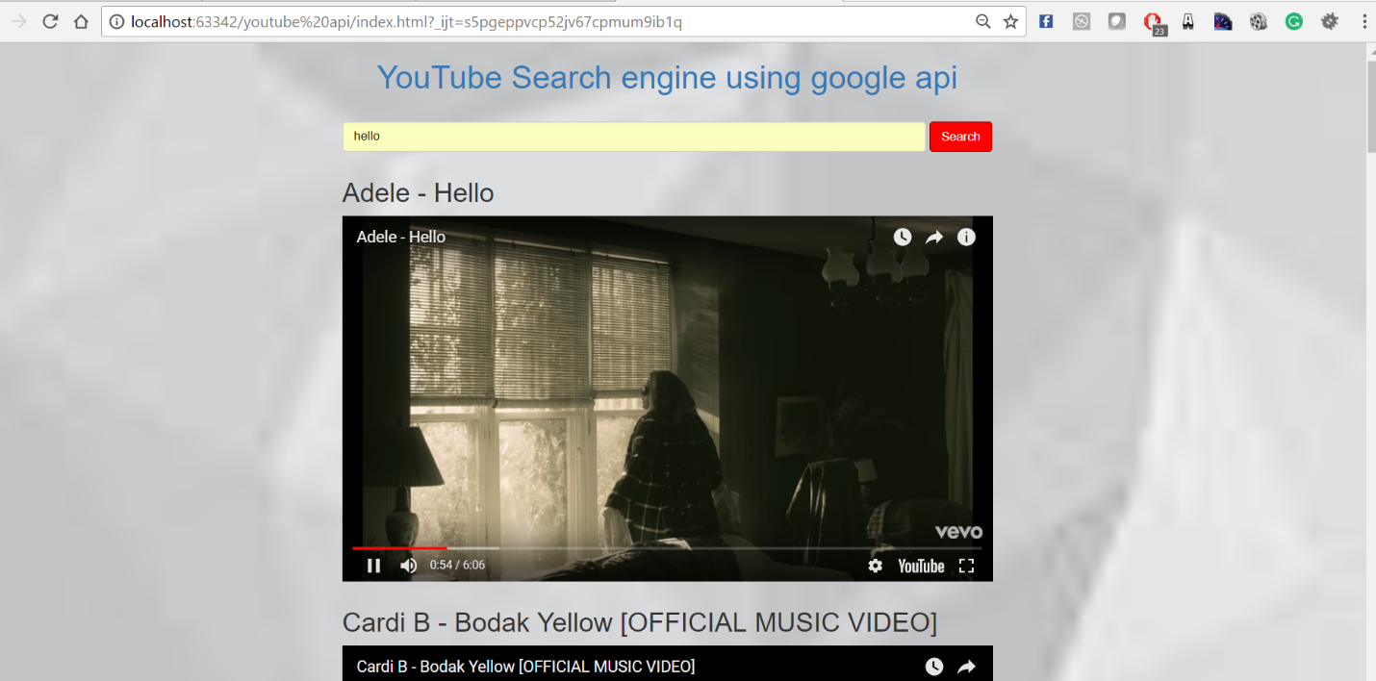

Another search result:

